Exercise 12. Steady-State, Transient Growth and the Determination of k_{L}a by the Dynamic Method

Prelab Questions

- Write a ‘biomass’ material balance around the chemostat. Next, assume a sterile feed and steady state; what surprising relation between the dilution rate and specific growth rate results?
- Experimentally, how could we achieve “washout” in a chemostat at steady state? What would you expect biomass and substrate concentrations to be under these conditions
- How is the overall oxygen transport resistance K_{g}a related to k_{g}a and k_{L}a?
- Explain how q_{O2}X wll be found in our experiment, and, using either derivative or integral method, how k_{L}a will be determined.

Establishing a Continuous Culture
A continuous culture experiment is difficult to perform because maintenance of a pure, uncontaminated culture is not easy. One way to avoid the difficulty is to use a drug resistant (e.g. streptomycin resistant) strain of microorganism and to add the drug to the medium, killing all other microorganisms. Or, one might use an organism that grows in a special medium (e.g. low pH, minimal medium) in which few other microorganisms can survive. Essentially, this would be setting up an enrichment culture for the organism. Or, if the organism has a particularly high growth rate, then a high dilution rate would wash out most other organisms. We will conduct a continuous culture experiment and hope that our aseptic technique will maintain a pure culture. It should be noted that even when aseptic technique is maintained, mutations may eventually effect a change in a culture given enough time.
The fermentor will be inoculated several hours before the experiment is to be done, so that the culture will be in exponential batch growth for the experiment. A feed system will be attached and set so that the dilution rate will be somewhat less than the maximum growth rate.

Determination of k_{L}a
There are several approaches to determine k_{L}a in aerated bioreactors. These are generally classified as static or dynamic methods. Both methods require a reaction in the liquid phase to reduce the dissolved oxygen concentration to a level below saturation. This reaction is generally the microbial consumption of oxygen. We do not need to know the kinetics of the reaction provided that the measurements can be taken over a sufficiently short period that the liquid phase oxygen concentration is essentially constant.

The Dynamic Method
The dynamic method for k_{L}a determination is based on the response of the dissolved oxygen concentration to changes in the inlet gas phase oxygen concentration. In this case we employ the well-mixed liquid phase oxygen balance equation and represent the gas phase mole fraction of oxygen by y^{ave}, which we assume to be constant. This is tantamount to assuming that the dynamics of the gas phase response can be neglected; the change in y^{ave} with time is sufficiently small that it does not influence the liquid phase balance equation. As the saturation concentration of dissolved oxygen in fermentation broths is quite small, this is a reasonable assumption.

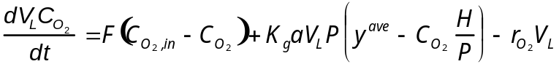 Eq (1)

In batch reactors there is no liquid flow into the tank and F is zero. Even in continuous reactors the magnitude of the terms F.C_{O2} for inlet and outlet are small with respect to the mass transfer and reaction terms in the above equation, as k_{L}a (order 10² hr⁻¹) is usually much greater than the dilution rate F/V_{L} (order 10⁻¹ hr⁻¹). Thus the above equation may be simplified for both batch and continuous operation to:
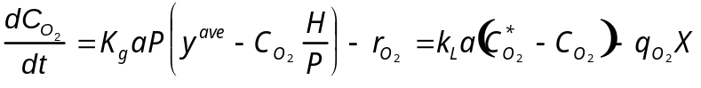
Eq (2)

If the dissolved oxygen concentration is monitored with a dissolved oxygen electrode, this equation can be employed to determine k_{L}a by first halting aeration of the fermentation broth. If the gas phase disengages quickly from the liquid and there is no surface aeration (this can be ensured by sweeping the surface with an inert gas such as nitrogen), then the transport term disappears from the above equation and it reduces to:
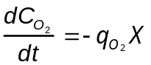
Eq (3)

where q_{O2}X is the microbial volumetric rate of oxygen consumption. Provided that this non-gassing period is short, the microbial suspension will continue to respire at the same rate as that obtained during gassing and the dissolved oxygen will fall linearly with time. We assume that C_{O2} is sufficiently high so that the specific oxygen consumption rate remains constant, independent of C_{O2}; i.e., it must remain above the critical concentration. If aeration is now resumed, Eq (1) can be rearranged to give:
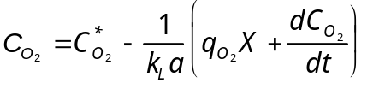
Eq (4)

If C_{O2} is recorded as a function of time, a plot of C_{O2} against dC_{O2}/dt has a slope of -1/k_{L}a. Hence k_{L}a can be determined.

The Integral Method
If q_{O2}X is obtained from the non-gassing period, we can avoid graphically differentiating the experimental C_{O2} versus time data by integrating a rearrangement of the above equation.

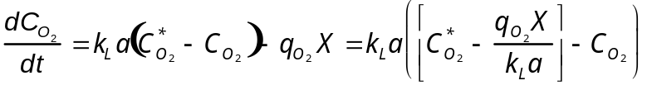 Eq (5)

and integrating:

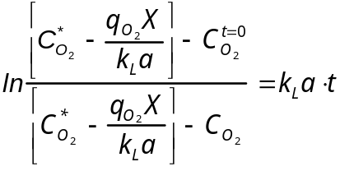 Eq (6)

We note that upon re-aeration, the value attained by the dissolved oxygen after the steady state is reestablished is given by
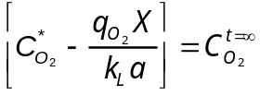
Eq (7)

thus the equation above can be written in terms of measurable quantities:
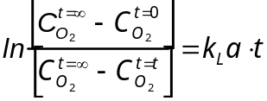
Eq (8)

By plotting the log term against time, kLa can be directly obtained from the slope.

With either of these two graphical approaches for k_{L}a determination, a value for C_{O2}* can be obtained. This corresponds to an average mole fraction of oxygen in the gas phase (C_{O2}* = Py^{ave}/H). If the value of y^{ave} obtained from this equation corresponds to the exit gas stream oxygen mole fraction, then the gas phase can be assumed to be well mixed. If it corresponds to a log mean of the inlet and exit gas phase mole fractions, then the gas phase behavior is plug flow. The dynamic method for obtaining k_{L}a has the advantage of not requiring prior knowledge of the flow behavior of the gas phase. The oxygen balance equation for a well-mixed liquid simply requires an average value be used to describe the gas phase mole fraction.

The dynamic method is very commonly used in large and small scale equipment, as sterilizable oxygen electrodes permit k_{L}a to be determined during a fermentation without causing significant disruption to the culture. This has the advantage that the k_{L}a is found using the actual fermentation broth even when the broth is viscous.

There are considerations that must be addressed with the dynamic method. Most dissolved oxygen electrodes have a substantial response time (of order 30 seconds to several minutes), so that changes in the actual value of C_{O2} in the broth are not recorded until some later time. The probe readings must therefore be reanalyzed to obtain the true values of k_{L}a.

Procedure

Day #1: Establishing Continuous Growth
This part of the procedure will be done one day prior to your coming to the lab. Even though you do not actually have to do this part, you should still understand it and complete the calculations requested.

- The glucose concentration in the M9 medium you will use is 0.1%. Assume D_{max} is 0.01 min⁻¹. The reactor working volume is 2 liters. Determine the inlet flow rate of medium, in L/hr, to achieve a dilution rate that is 50% of D_{max}.

- Steady state will be achieved in the reactor as follows:
- The dissolved oxygen (DO) probe will be calibrated to 0% and 100% with M9 medium only in the fermentor. The agitation rate will be set to 150 RPM.
- The fermentor will be inoculated with 10 ml of an overnight (stationary phase) culture of E. coli TOP10.
- Once the culture reaches late exponential phase, the inlet and outlet pumps will be started. A sample will be taken to measure OD.
- The inlet flow rate is set to achieve the dilution rate calculated above. The outlet port is set at the 2 L level. The outlet pump operates at the same rate as the inlet pump.

- The fermentor will be allowed to run overnight to achieve steady state.

Day #2: Wash Out and the Determination of k_{L}a

- The reactor should now be in steady state. Take a sample and measure the OD600. To ensure steady state, wait ten minutes and take a second sample.

- The first step in determining k_{L}a is obtaining a value for q_{O2}X. Turn off the air sparger, and immediately start recording the DO reading. Use the house nitrogen line connected to a sterilized air filter to inject N₂ into the reactor for 5 seconds. (Your lab partner or the TA should do this as you are timing for the first reading.) Record the DO reading every 10 seconds for two minutes. Do not allow the DO reading to drop below 20%.

- After two minutes, set the air sparger to ~2. Keep timing as in step 5 and record the DO every 10 seconds initially. Once the rate of increase stabilizes, record the DO every minute, until a steady state has been reached.

- Repeat steps 6 and 7, using agitation speeds of 350 and 400 RPM.

Guidelines for Analysis & Conclusions Section
(Remember, these are points you should consider and include in your analysis. This section, however, need not be limited to these specific guidelines.)

1. Perform mass balances around the fermenter for the cell and substrate concentrations. Use these equations and your values for μ_{max} and K_{s} from the previous experiment to predict the steady state concentrations (X_{ss} and S_{ss}). Also, calculate D_{max} based on the values you obtained previously and the inlet substrate concentration of 0.1% glucose.

2. Determine the values of q_{O2}X and k_{L}a, by both the integral and derivative methods. Do this for all three impeller speeds. In order to find the derivative you will need to fit a function through your oxygen concentration vs. time plot. From your results and past experience which do you feel is more reliable, the integral or the derivative method?

3. Determine whether the relationship between impeller speed and k_{L}a fits that predicted by the theoretical mass transfer. Use equation 5.126 in Blanch and Clark (v_{s} is the superstitial gas velocity). In order to find the power (P), use the Figure 5.20 to get a Power number from the Reynolds number. We are using 6 cm diameter disk type impellers. Under the operating conditions of our fermenters the Power number should be constant. Use equation 5.160 to find a relation between impeller speed (N, in rpm) and power. Make a plot of experimentally determined N vs. k_{L}a. Does the relation between these two behave as the theory predicted?

4. Perform a mass balance around the fermentor for the cell concentration during the washout phase (i.e. non-steady state). Using this equation, calculate the flowrate required to achieve washout in 4 hours.

EQUIPMENT AND REAGENTS
Bioflo III fermentors with 1 liter of exponentially growing Escherichia coli in M9 medium
1X M9 medium with 0.1% glucose, 15 liters
1.5 ml microcentrifuge tubes
Spectrophotometer
Disposable cuvettes
Media supply carboy
Waste carboy
Sigma Glucose (Trinder) Assay Kit

REFERENCE
Blanch, H.W., and Clark, D.S. (1996) Biochemical Engineering, pp. 353-413, Marcel Dekker, Inc., New York.

